PORTRAITS IN WATERCOLOUR 2 day Workshop
with Jan Lawnikanis 26-27 March, 2019
COOCHIE ART GROUP

MATERIALS LIST
PAINTS: A range of professional quality watercolours and a palette with plenty of room for mixing paints. Include some transparent pigments; either the CMY palette Jan has taught with previously, or other transparent colours for mixing.
BRUSHES: Designated watercolour brushes in different sizes, including fine point ‘rounds’ for detail.
PAPER: 100% cotton watercolour paper, 300gsm in either Smooth (Hot Press) or Medium texture, at least A4 size. HP is preferable though. Either buy a full sheet that can be cut to size (1 sheet will be enough for this workshop) or buy a pad or block of paper.
OTHER BASICS: 2 water pots, old towel or rags, tissues, a board larger than your paper, masking tape. A pipette or medicine dropper. 1 sheet of graphite transfer paper.
STATIONERY: Pen and paper for writing notes. Graphite pencil, eraser and scissors.
REFERENCES: Jan will bring some printed references for day 1, but please bring a good quality colour portrait photo of your choosing for day 2. It must be cropped to head and shoulders only and printed at a size large enough to see details. If you are not confident to draw the person freehand, then also bring an A4 photocopy to transfer. If you don’t have a quality photo to work from, there are some that can be printed from copyright-free sites. Just check that they are indeed free to use for any purpose! Find ones that are natural-looking rather than highly edited.
https://unsplash.com/search/photos/portrait
https://www.pexels.com/search/portrait/
https://pixabay.com/images/search/portrait/

If you have any questions about this list, feel free to contact me. Looking forward to painting with you!
Jan Lawnikanis 0410819926 jlawnikanis@gmail.com www.janlawnikanis.com

PORTRAITS IN WATERCOLOUR 2 day Workshop
with Jan Lawnikanis 26-27 March, 2019
COOCHIE ART GROUP
ABOUT THIS WORKSHOP
DAY 1: With a limited palette and reserving the white of the paper for the lightest areas, Jan will teach you a simple method of portrait painting that can be quickly achieved with the right kind of reference. Students will all paint from the same small reference together. Another portrait can be started in the afternoon session using the same methods but with a different colour palette and new reference.
DAY 2: After analysing different skin colours, students will practise mixing paint colours to match the subject. Quick studies of facial parts will follow before starting on individual paintings in a more realistic style than on day 1.

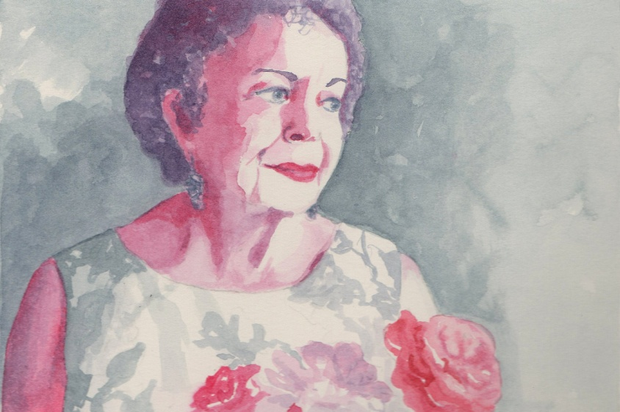
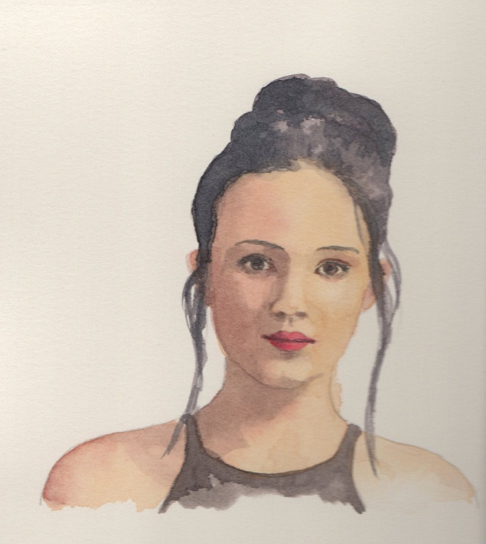
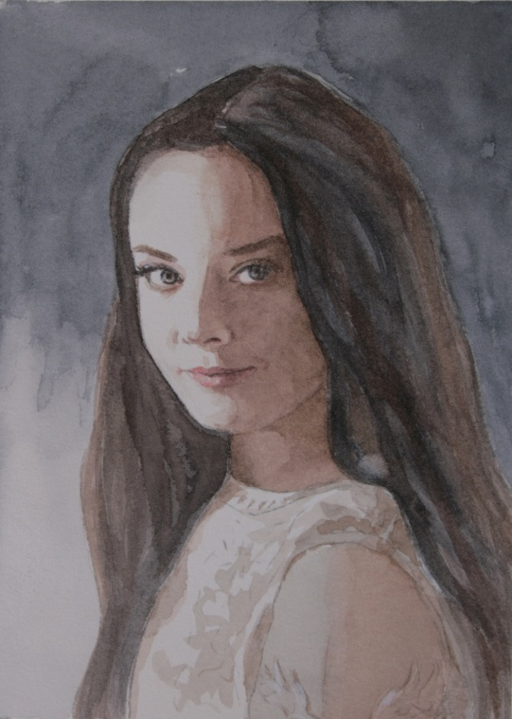
Day 1 examples

Day 2 example

